Names ___________________________ Thermochemistry and Hess’s Law

Introduction
In this experiment, you will test the validity of Hess's Law, which says for any state function (state property), such as internal energy (E) or enthalpy (H), the value for a change in that function will be identical, whether it is obtained from one chemical reaction directly or from a series of reactions in any order. To do this, you will measure the amount of heat, ΔH, produced or absorbed in several reactions carried out under conditions of constant (atmospheric) pressure. The quantity of heat transferred in each case will depend on energy changes resulting from the breaking and making of bonds, and from interactions of ions in aqueous solution.

The test reactions are to be carried out in styrofoam coffee cups. Although polystyrene is a reasonably good insulator, a small amount of heat will be lost from the cup. We will make the assumption that this amount is negligible. The calorimeter (heat-measuring device) consists of the coffee cup, a magnetic stir bar and a thermometer.

An exothermic reaction, for example, carried out in the calorimeter will give off heat (exit). Nearly all the heat of the reaction must be absorbed by (a) the solution in the calorimeter and (b) the calorimeter itself. The temperature changes that occur depend on the heat capacities of the solution and the calorimeter. The heat capacity, C, describes how much heat is required to change the temperature of the substance by 1°C; typical units for heat capacity are Joules/°C (J/°C). For solutions that may have varying masses, a more convenient term (or a better standard) is specific heat capacity, c, which is just heat capacity per gram; typical units are J/[g ·°C]. The most general equation for heat flow is given below:

q = m · c · ΔT

q is the heat transferred and is equal to ΔH at constant pressure, ∆T is the observed change in temperature of the solution (°C), c is the specific heat capacity (per gram of solution, J/[g ·°C]), and m is the mass of the solution (grams). (Note: C = m·c)

Since ΔHsys + surr = ΔHreaction + ΔHsolution + ΔHcalorimeter and ΔHsys + surr = 0
then ΔHreaction = – [ ΔHsolution + ΔHcalorimeter]

The last equation simply says that the amount of heat given off by the reaction will be equal to the heat absorbed by the calorimeter and the solution that it contains (note: just the opposite is true for an endothermic reaction). The negative sign indicates the direction of the heat flow (out one part and into another).

This experiment has seven parts. In part I, you will determine the heat capacity of your calorimeter. In parts II and III, you will measure the heat produced by two different reactions: the precipitation of calcium hydroxide when calcium nitrate and sodium hydroxide are mixed, and the neutralization reaction between the precipitate above and nitric acid. In parts IV and V, you will measure the heat produced when the order of addition is changed. In Parts VI and VII, you will change the order of addition a third time and measure the heats of reaction. This information should allow you to test the validity of Hess's Law.

Notes:
- Your calorimeter will consist of a styrofoam coffee cup, magnetic stir bar, and a temperature probe.
- Weigh the calorimeter and its contents on a top-loading balance (your temperature probe is not included in this weight).
- Temperatures will be recorded and graphed using computer interfacing equipment and software to be described by instructor and lab assistant.
- Temperature changes will be determined from the graphs as described in the experiment.

Safety

CAUTION: Nitric acid (HNO₃) and aqueous sodium hydroxide (NaOH) can be irritating or painful if spilled on your skin. Both can cause severe damage if splashed in your eyes. You MUST wear your safety goggles when handling these materials. Any spills on eyes or skin should be immediately flushed with large amounts of water. Take great care not to spill on the computers!!
Procedure I: Determination of the Calorimeter Constant

In the first part, you will determine a calorimeter constant, C_{cal}, which is the amount of heat required to raise the temperature of the calorimeter (cup, stirrer, and probe tip) by one degree. It is important to know how much of the heat of a reaction is being used just to heat up the calorimeter, and therefore will not show up as heat produced in the reaction. To find out how much heat the calorimeter requires, you will mix known amounts of hot and cold water.
- Put 50 mL of d.i. water in a 250 mL Erlenmeyer flask and heat it gently on a hot plate until the temperature is about 50° (use lab-drawer thermometer).
- Put another 50 mL of d.i. water in a beaker.
- Weigh your empty, dry calorimeter (coffee cup and a magnetic stir bar).
- Pour the hot water into the calorimeter and weigh it again quickly.
- Set up the apparatus including a stirrer. Turn on the stirrer (not the heat) - it should be stirring at a moderate rate without splashing - and begin recording temperature readings of the warm water with the interfacing software continuously for four minutes. Simultaneously, your partner should record the temperature of the cool water (step 1) every 30 seconds using drawer thermometer. [At the end of the four minutes, the temp of the hot water should still be 15–30° warmer than the cool water.]
- At the four minute mark, quickly pour the cool water into the calorimeter. Continue reading and recording the temperature of the calorimeter solution for another four minutes. The temperature should then be dropping very slowly and regularly.
- Weigh the calorimeter with its contents to determine the exact weight of cool water that was added.
- Calculate C_{cal} and report to instructor before proceeding.
Procedure II: Precipitation of Calcium Hydroxide

In this first reaction, aqueous calcium nitrate is treated with sodium hydroxide, precipitating calcium hydroxide. The amount of heat produced in this reaction will be ΔH2.
Ca²⁺_{(aq)} + 2OH–_{(aq)} → Ca(OH)_{2(s)}
- Weigh your wet calorimeter (cup and stir bar). Measure 20.0 mL of 3.00 M Ca(NO₃)₂ from the proper buret into the cup. Weigh and record the cup, stir bar and solution. Turn on the stirrer and record the initial temperature of the solution by the probe reading. It should remain essentially constant.
- Measure out 25.0 mL of 4.00 M NaOH into a clean beaker (mark as NaOH) and record its initial temperature with the clean, dry probe; it should be essentially constant.
- Put the probe back in the calorimeter. Pour the NaOH solution into the calorimeter and immediately record temperatures continuously for 4 min until the temperature is changing slowly and regularly.
- Weigh the calorimeter again to determine the exact weight of NaOH solution that was added. Save the solution in the cup for Part III.
Procedure III: Addition of Nitric Acid to Calcium Hydroxide Precipitate

In this second reaction, nitric acid is added to neutralize the precipitated calcium hydroxide. The amount of heat produced in this reaction will be ΔH3.
2H⁺_{(aq)} + Ca(OH)_{2(s)} → 2H₂O_{(l)} + Ca²⁺_{(aq)}
- Measure 30.0 mL of 4.00 M HNO₃ into a clean beaker (mark as HNO₃) and record its initial temperature, which should be essentially constant.
- Set the stir bar spinning at a moderate rate. Record the initial temperature of the solution in the calorimeter from Part 2. Pour the HNO₃ solution into the calorimeter and immediately record the temperature continuously for 4 min until the temperature is dropping slowly and regularly.
- Weigh the calorimeter again to determine the weight of HNO₃ solution that was added. The solution in the cup may now be discarded.

Procedures IV-VII: Alternative Sequences for the addition of reagents

**Read this section carefully before beginning!!**

Using identical volumes of the three solutions used above, repeat the procedure of Parts II and III, but add the reagents in a different sequence. In each trial, you should use 20.0 mL of Ca(NO₃)₂, 25.0 mL of NaOH and 30.0 mL of HNO₃. Only the sequence in which reagents are added will vary. You must obtain results for three sequences. The first you just completed, and the other two are outlined below:

Sequence B Part IV: add nitric acid to calcium nitrate.
Part V: add sodium hydroxide to the above solution.

Sequence C Part VI: add nitric acid to sodium hydroxide.
Part VII: add calcium nitrate to the above solution.

**Of course, you must weigh before and after each addition so that you know the weight of solution added each time. Do not forget to record the initial temperatures of the solutions immediately prior to addition. Record the changes in temperature in the same manner as above.

Graphs

Your lab group will need to submit seven graphs of temperature vs. time, one for each part of the experiment. An example for Part I is shown below. Notice that temperature readings for the four minutes prior to mixing are required for Part I only. For Parts II-VII, one initial reading will be sufficient, followed, of course, by the four minutes of temperature readings after the "time of mixing."
Part I (see example): The temperature of the hot water will be slowly falling and the cool water should be essentially unchanged before mixing. Just after the solutions are mixed, the thermometer readings will decrease rapidly according to a curve. Eventually, the temperature will begin to fall slowly and regularly, and the data points will follow (approximately) a straight line. You will use the points on this linear portion to extrapolate back (draw a straight line with the computer software) to the time of mixing mark (t = 4 min for Part I, t = 0 sec for all other parts). Use this temperature as your T_{final} to calculate ΔTh and ΔTc, where
ΔT = T_{final} – T_{initial}
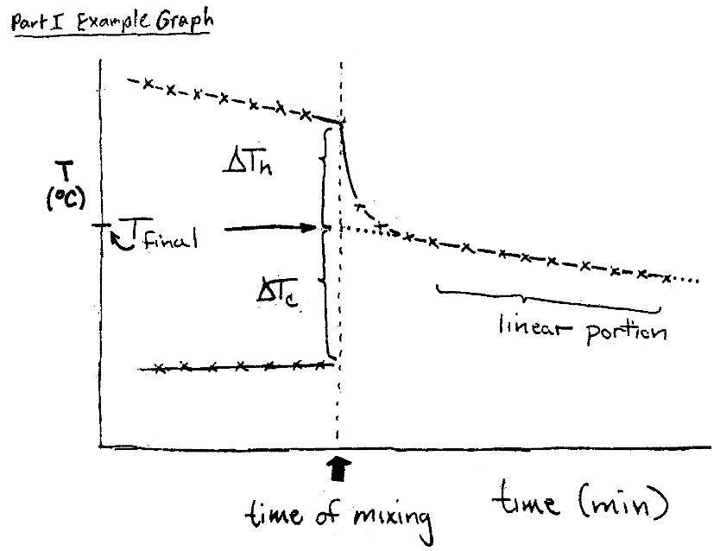

Data Sheet
Part I: Calorimeter calibration - to determine Ccal):

Initial temp of cool water (just prior to mixing) ___________ºC
Initial temp of hot water (just prior to mixing) ___________ºC
Mass of dry calorimeter (cup and stirrer) ___________ g
Mass of hot water and calorimeter ___________ g
Mass of hot water alone ___________ g
Mass of "cool /hot water mixture" and calorimeter ___________ g
Mass of cool water alone (subtract hot and calorimeter) ___________ g
Final temp of "cool/hot water mixture" ___________ ºC

Changes in temperature (final minus initial) determined from graphs:
ΔTc ____________ ºC
ΔTh ____________ ºC
Tips for calculating the calorimeter constant:
Subscripts c and h refer to cold or hot water in calibration. Use cw = 4.18 J/(g·°C) for pure water.

ΔH1 = −(ΔHc + ΔHh)
ΔHc = mc·(cw)·ΔTc
ΔHh = mh·(cw)·ΔTh

ΔH1 = Ccal ΔTh Ccal = calorimeter constant (J/°C)

Parts II – VII
 | Part II  (A) 20.0 mL Ca(NO₃)₂  (B) 25.0 mL NaOH | Part IV  (A) 20.0 mL Ca(NO₃)₂  (B) 30.0 mL HNO₃ | Part VI  (A) 25.0 mL NaOH  (B) 30.0 mL HNO₃
Mass of damp calorimeter (g)
Mass of solution and calorimeter (g)
Mass of sol’n A alone (g)
Mass of all sol’ns in calorimeter (g)
Mass of sol’n B alone (g)
Initial temp. of sol’n A (°C)
Initial temp. of sol’n B (°C)
Final temp determined from graph (°C)
ΔT_{A} (°C)
ΔT_{B} (°C)
 | Part III  (A) Ca(NO₃)₂ & NaOH  (B) 30.0 mL HNO₃ | Part V  (A) Ca(NO₃)₂ & HNO₃  (B) 25.0 mL NaOH | Part VII  (A) NaOH & HNO₃  (B) 20.0 mL Ca(NO₃)₂
Mass of all sol’ns and cal. (g)
Mass of combined sol'n (new A) (g)
Mass of added sol’n alone (B) (g)
Initial temp. of sol’n A (°C)
Initial temp. of sol’n B (°C)
Final temp determined from graph (°C)
ΔT_{A} (°C)
ΔT_{B} (°C)

Tips for calculations for parts II - VII:

Use ca or b = 3.70 J/(g·°C) for all solutions other than pure water. This value is an approximation, but will introduce only a small amount of error into the calculations. For precision, the heat capacities of each solution would have to be determined in a separate experiment.

–ΔH_{x} = m_{A}·(c_{A})·ΔT_{A} + m_{B}·(c_{B})·ΔT_{B} + C_{cal} ΔT_{A}

A = solution of whatever is in the cup
B = whatever solution is added to that in the cup
x = 2, 3, 4, 5, 6, 7 for heats of reaction for Parts II–VII, respectively

Results

Heat gained by cold water, ΔHc _____________
Heat lost by hot water, ΔHh _____________
Calorimeter constant, Ccal _____________
[* Expect 0 < Ccal < 100 J/°C. Use 0 or 100 if your value is outside the range.]

Heat of precipitation, ΔH₂ _____________
Heat of neutralization, ΔH₃ _____________
ΔH₄ _____________
ΔH₅ _____________
ΔH₆ _____________
ΔH₇ _____________

Hess's Law predicts:
ΔH₂ + ΔH₃ = ΔH₄ + ΔH₅ = ΔH₆ + ΔH₇

but this equation is only valid if an equal amount of NaOH is used for each pair of reactions. This is because the NaOH is the limiting reagent in the exothermic and endothermic reactions. The simplest way to balance the heats is to simply divide by the grams of NaOH solution used for each pair of reactions:

[ΔH2 + ΔH3]/m2,3 = [ΔH4 + ΔH5]/m4,5 = [ΔH6 + ΔH7]/m6,7

where mx,y is the mass of 4 M NaOH used in Parts X and Y (approx. 27 or 28 g for each). These three values should now be within 5% of each other.

[ΔH2 + ΔH3]/m2,3 = _________________
[ΔH4 + ΔH5]/m4,5 = _________________
[ΔH6 + ΔH7]/m6,7 = _________________

average [ΔHi + ΔHi]/mNaOH = _________________

largest % deviation from the average = _________________

Claim for Discussion:

Do your results generally concur with Hess’s Law? If not, suggest reasons for deviation.

